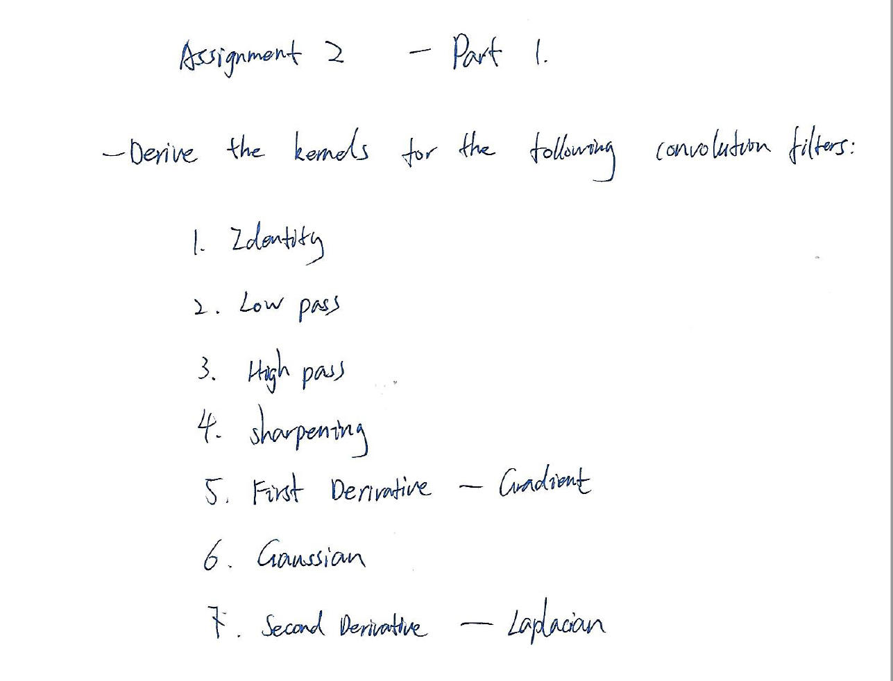











**Assignment 2 – Part 2**

**The simulation results for the following convolution filters:**

The main interface:

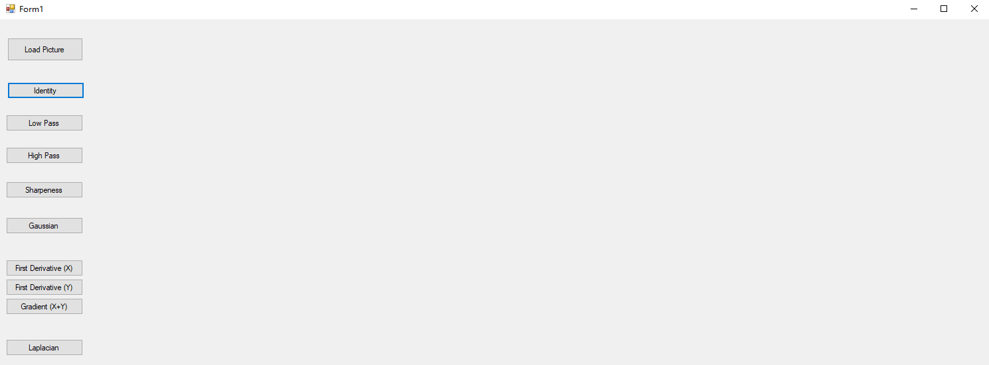

Step one: load the image:

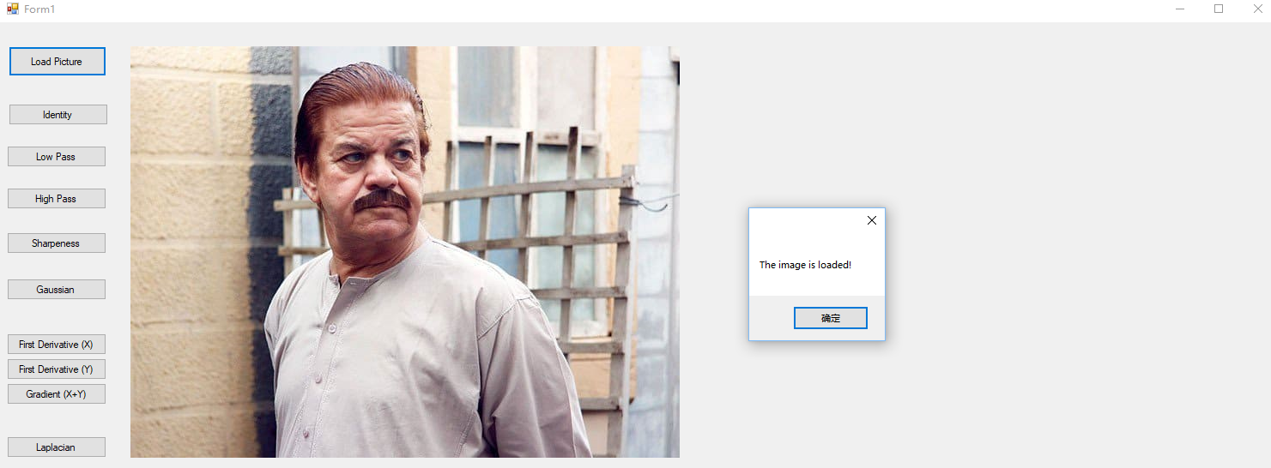

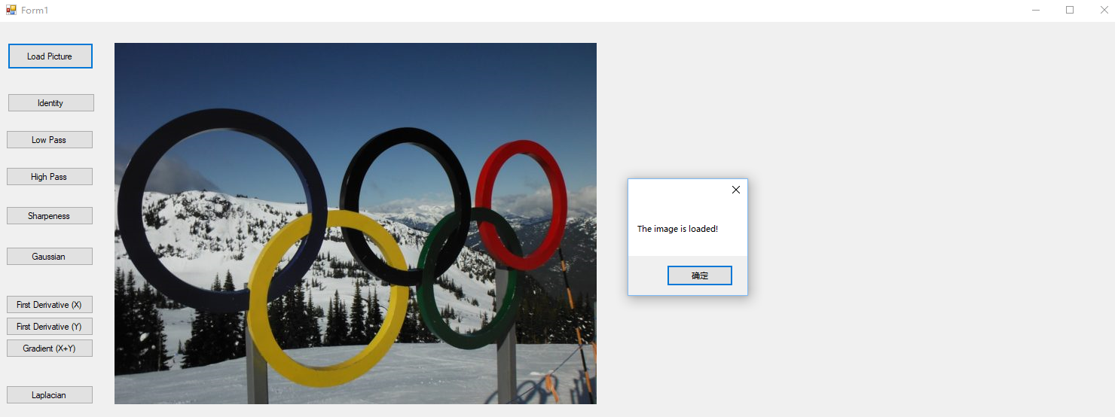

1. Identity Filter:

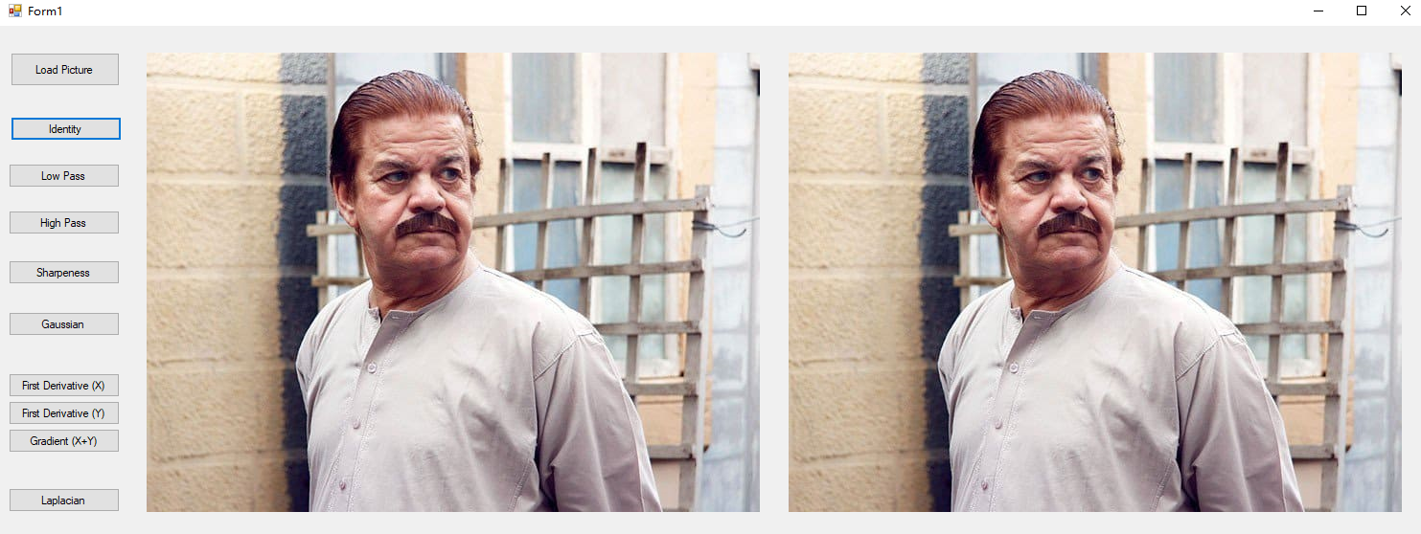

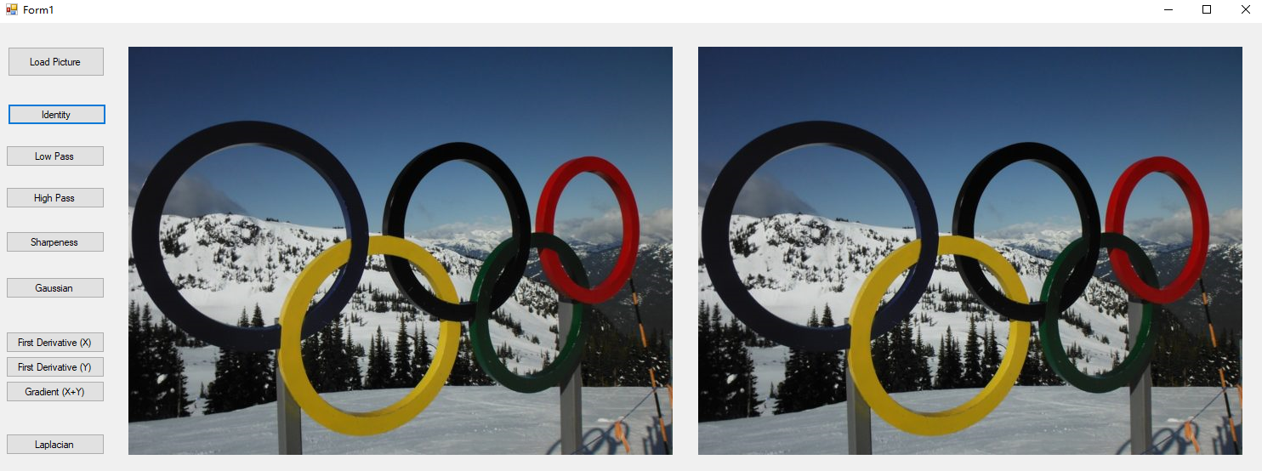

The identity filter used simulation is

|  |  |  |
| --- | --- | --- |
| 0 | 0 | 0 |
| 0 | 1 | 0 |
| 0 | 0 | 0 |

For the identity filter, the processed image is almost unchanged compared to the original image.

2. Low Pass Filter:

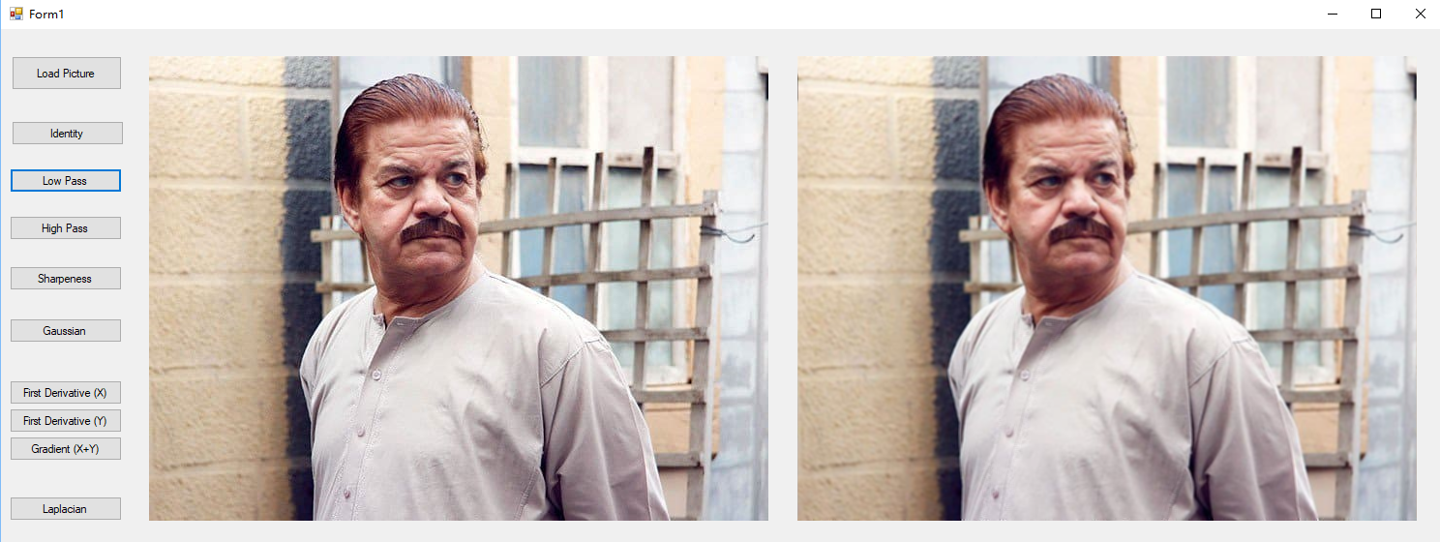

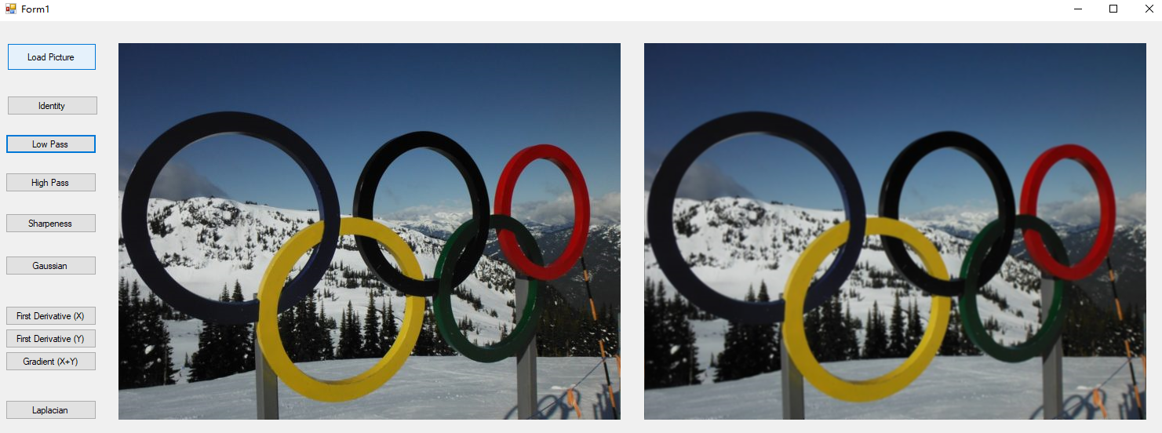

The low pass filter used in simulation is

|  |  |  |
| --- | --- | --- |
| 1/9 | 1/9 | 1/9 |
| 1/9 | 1/9 | 1/9 |
| 1/9 | 1/9 | 1/9 |

Passing the long wavelength only, the processed image got blurring compared to the original image.

3. High Pass Filter:

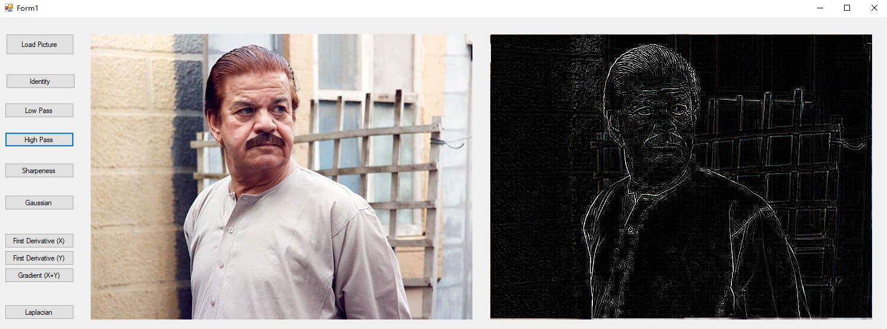

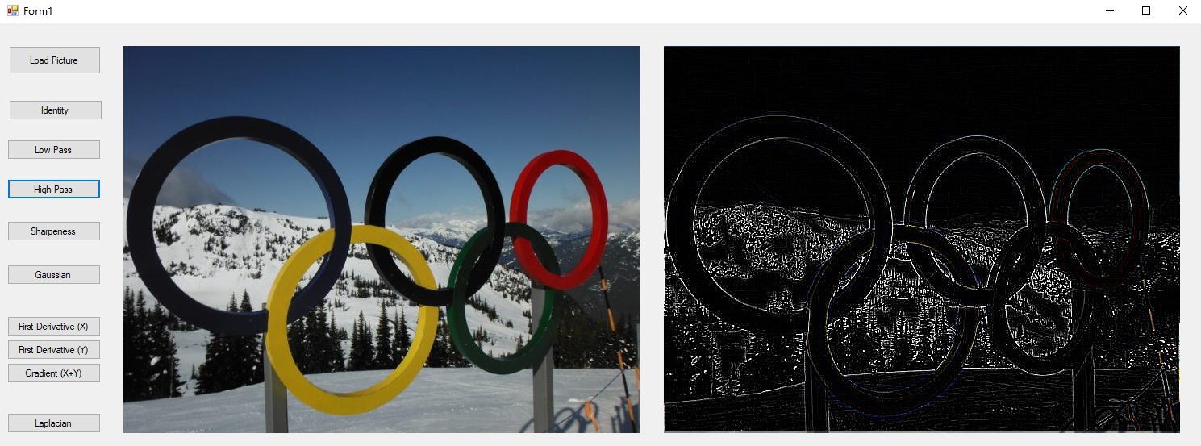

The high pass filter used in simulation is

|  |  |  |
| --- | --- | --- |
| -1 | -1 | -1 |
| -1 | 8 | -1 |
| -1 | -1 | -1 |

Passing the short wavelength only, the processed image extracted only the edges of the original image.

4. Sharpening:

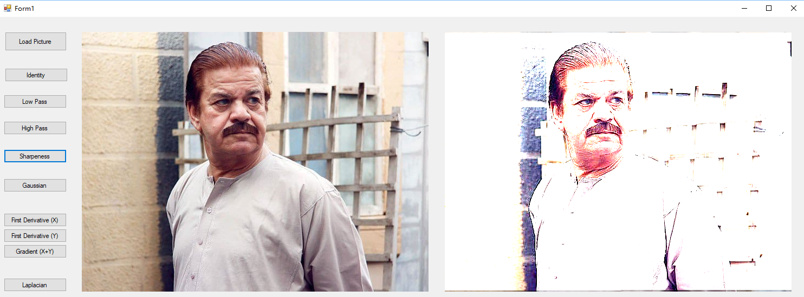

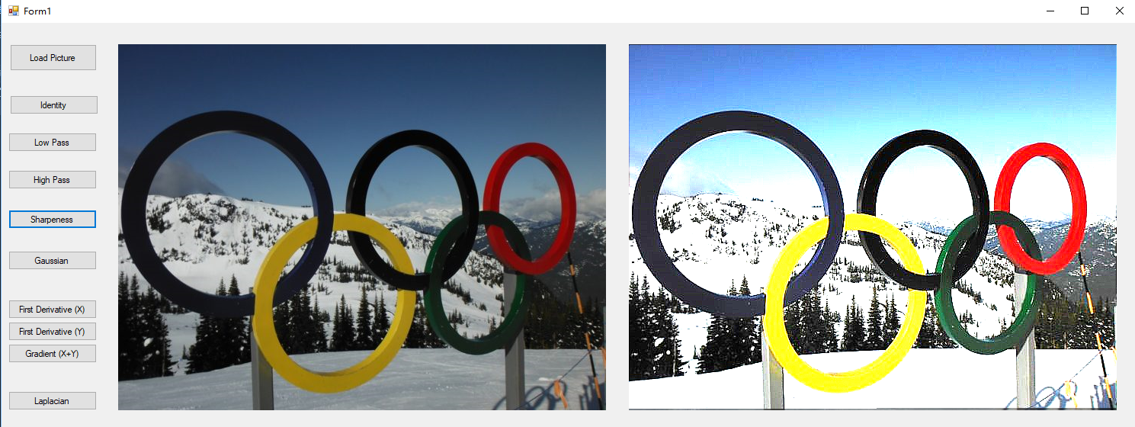

The filter used in simulation is

|  |  |  |
| --- | --- | --- |
| -f/9 | -f/9 | -f/9 |
| -f/9 | (-f+9)/9 | -f/9 |
| -f/9 | -f/9 | -f/9 |

Note: 0 < f < 1; here it takes f = 0.7.

Sharpened the image by blending or mixing the original image with the high pass filtered image.

S = (1-f)*I + f*h

5. Gaussian Filter:

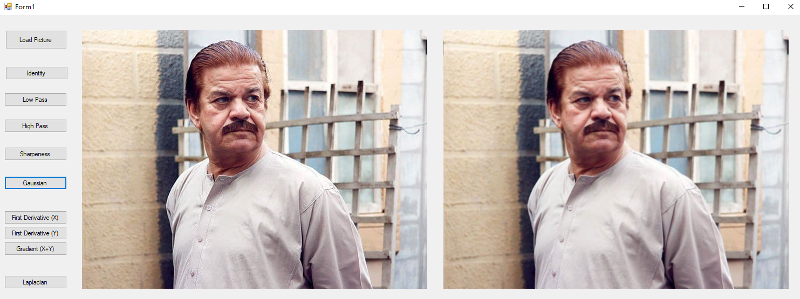

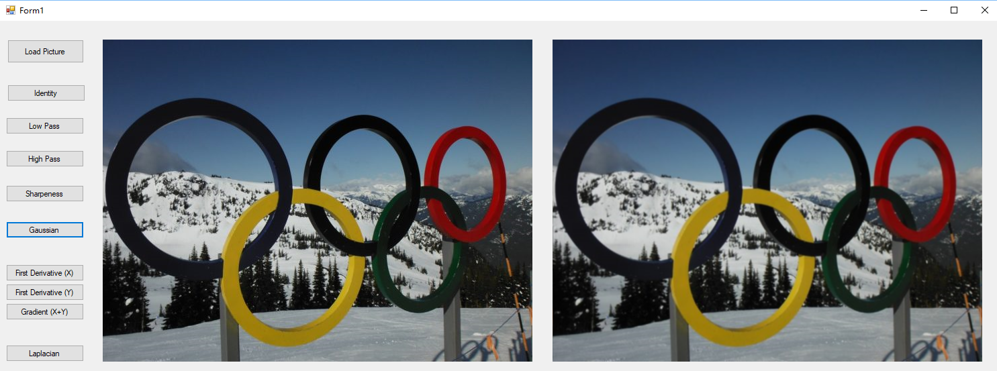

The filter used in simulation is (like low-pass)

|  |  |  |
| --- | --- | --- |
| 1/16 | 2/16 | 1/16 |
| 2/16 | 4/16 | 2/16 |
| 1/16 | 2/16 | 1/16 |

For the Gaussian filter, it is smoothing the image. If the standard deviation is very small, the filter works like the identity filter, which means the processed image has almost no change as the original one. If the standard deviation is very small large, the filter works like the low pass filter (likely taking average), which means the processed image will remove high frequencies noises in this case.

6-a. First Derivative Filter (X direction only):

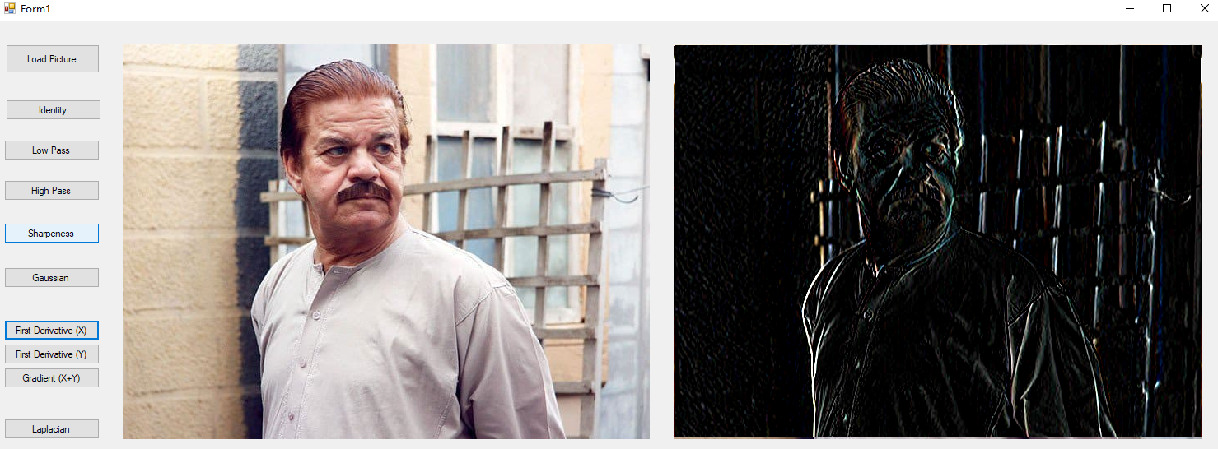

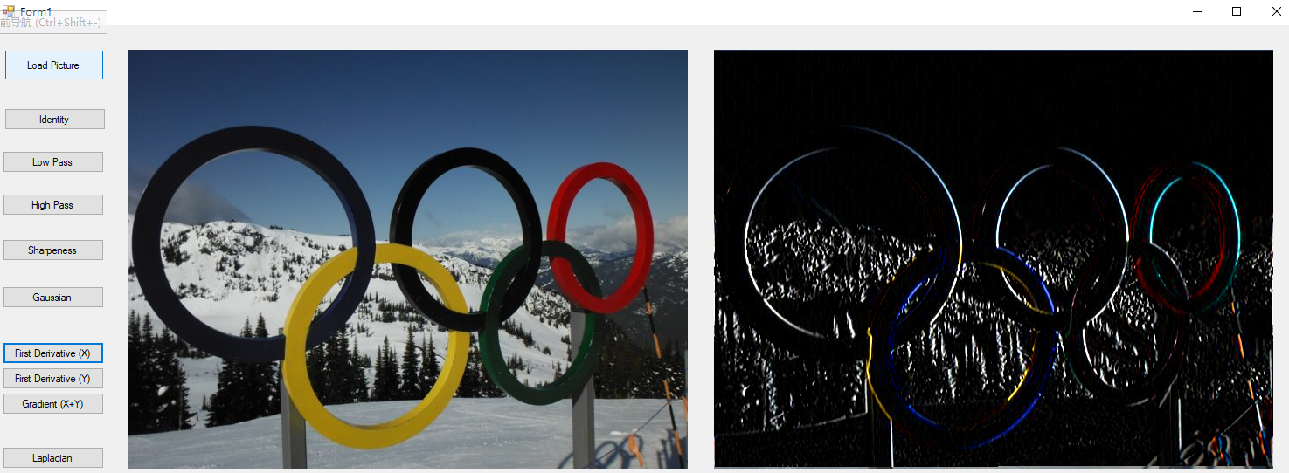

The first derivative filter used in simulation is

|  |  |  |
| --- | --- | --- |
| -1 | 0 | 1 |
| -1 | 0 | 1 |
| -1 | 0 | 1 |

For edge detection, the result showed that all edges that rapidly changed in the image intensity along horizontal scanline has been extracted.

6-b. First Derivative Filter (Y direction only):

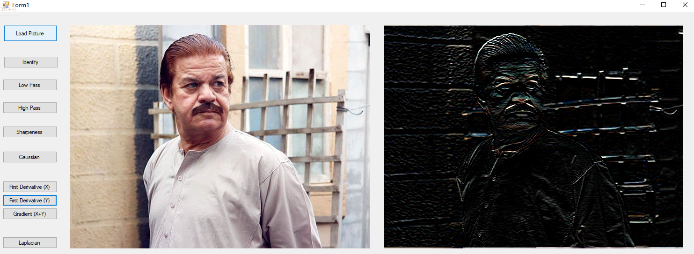

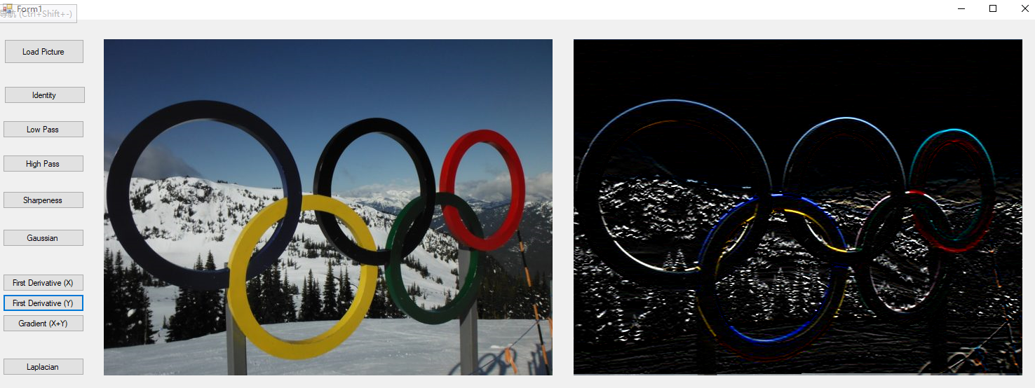

The first derivative filter used in simulation is

|  |  |  |
| --- | --- | --- |
| 1 | 1 | 1 |
| 0 | 0 | 0 |
| -1 | -1 | -1 |

For edge detection, the result showed that all edges that rapidly changed in the image intensity along vertical scanline has been extracted.

6-c. Gradient (First Derivative) Filter (both X and Y direction):

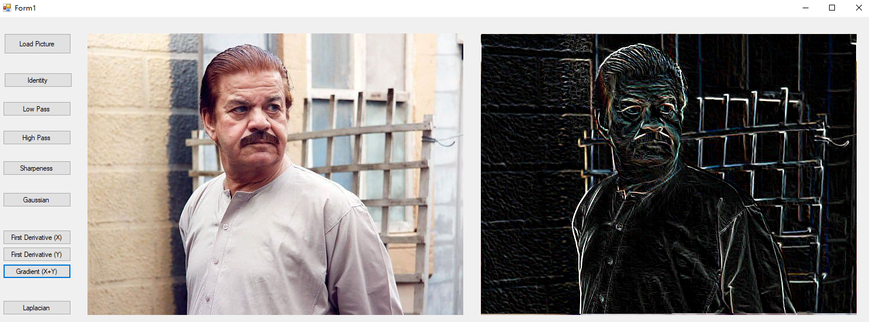

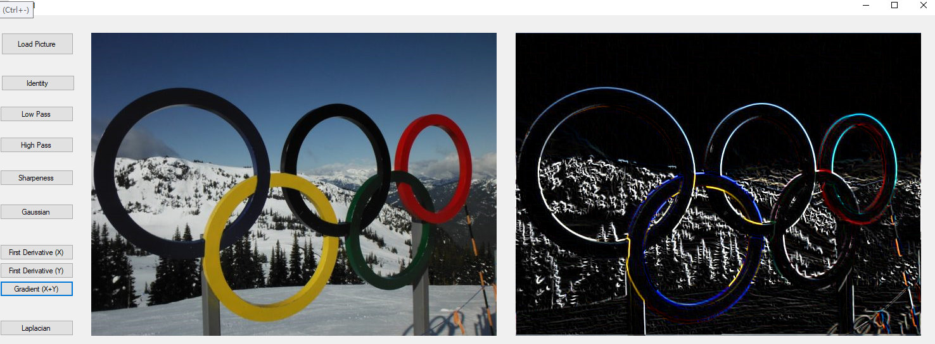

The first derivative filter = sqrt(sqr(dP/dx)+ sqr(dP/dy)).

For edge detection, the result showed that all edges that rapidly changed in the image intensity (along both horizontal and vertical scanline) has been extracted.

7. Laplacian (Second Derivative) Filter:

Case 1: neighbor = 4:

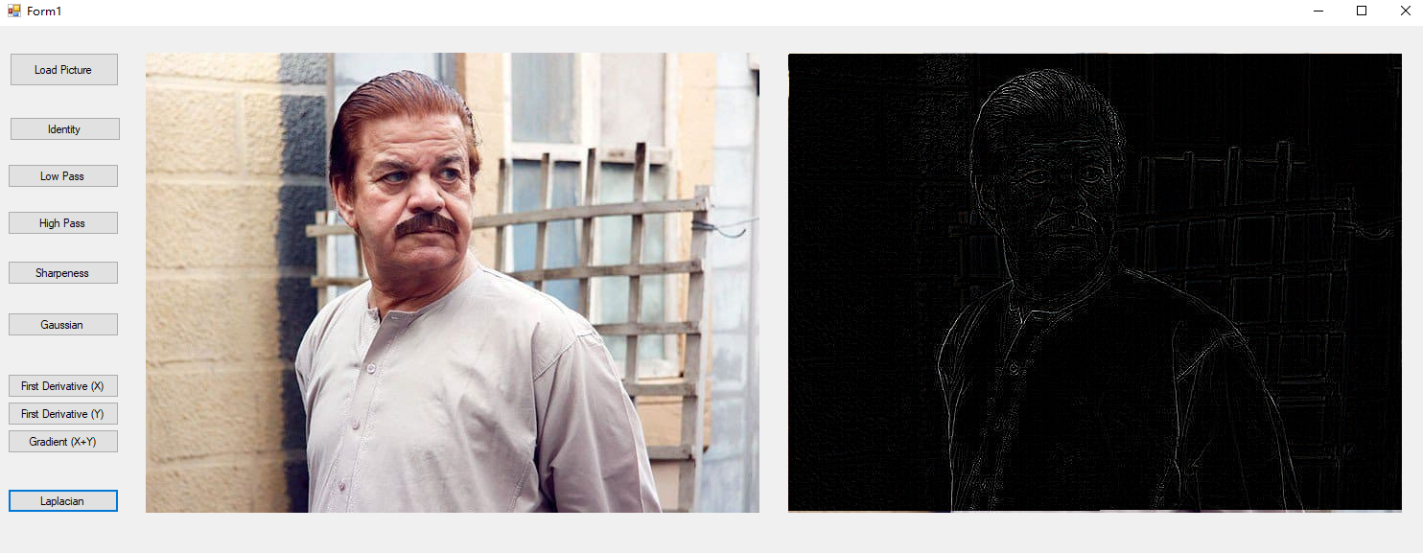

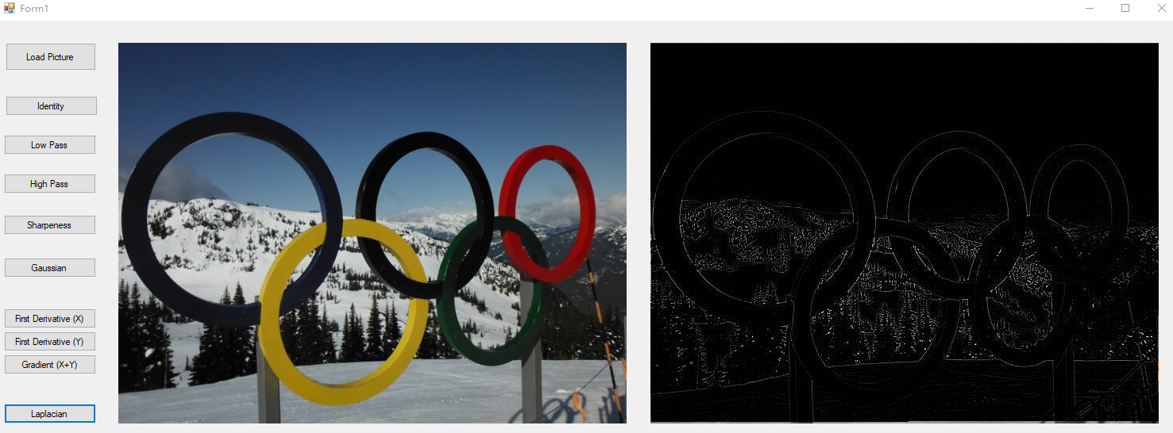

The second derivative filter used in simulation is

|  |  |  |
| --- | --- | --- |
| 0 | -1 | 0 |
| -1 | 4 | -1 |
| 0 | -1 | 0 |

For edge detection, edges were enhanced. The image has been sharpened.

Case 2: neighbor = 8:

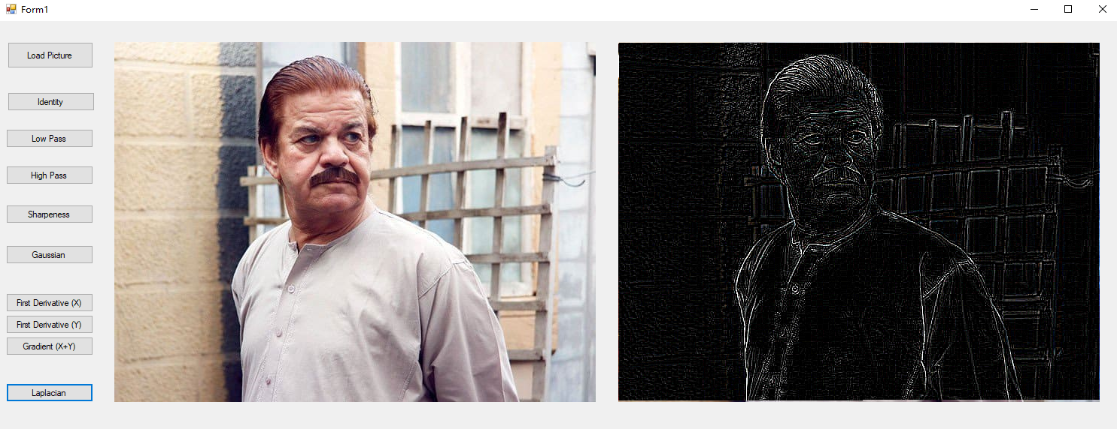

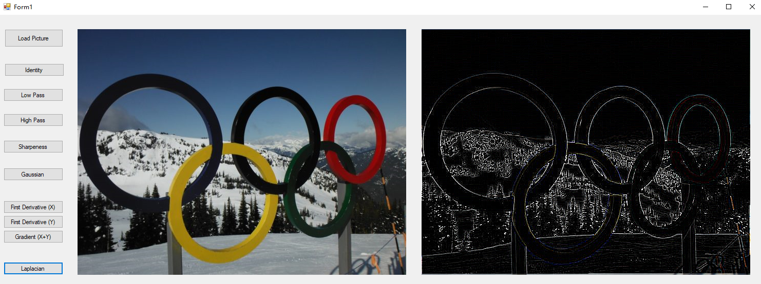

The second derivative filter used in simulation is

|  |  |  |
| --- | --- | --- |
| -1 | -1 | -1 |
| -1 | 8 | -1 |
| -1 | -1 | -1 |

For edge detection, edges were enhanced strongly than that of 4-neighbor type (same to high pass filter).